AM000-Asia-China-Han-Four Bat, Eight Arc

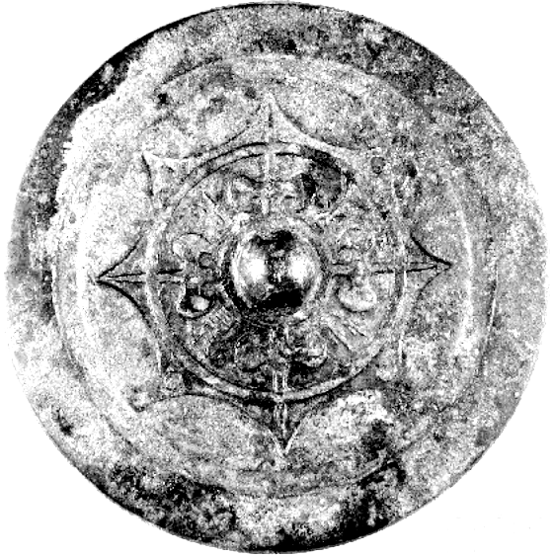

130mm

Han- Presentation mirror, Loyang.

This Han Presentation Mirror is a type of mirror offered as a present to an official with characters written in the "hanging needle" style with 4 bat (arrow-shaped) decorations.

Description: from the plain base of the knob project the four bat decorations and in the bat-free tips of the arc are placed the four characters of the inscription.

Reference: Reference: Robert W. Swallow, Ancient Chinese bronze mirrors. Rev. and enlarged ed. by Fred Belcher. Ann Arbor: Ars Ceramica, Ltd., 1977, Fig. 34.

